HOW TO CREATE A GITHUB ACCOUNT

1.OPEN GOOGLE CHROME AND SEARCH GITHUB.COM

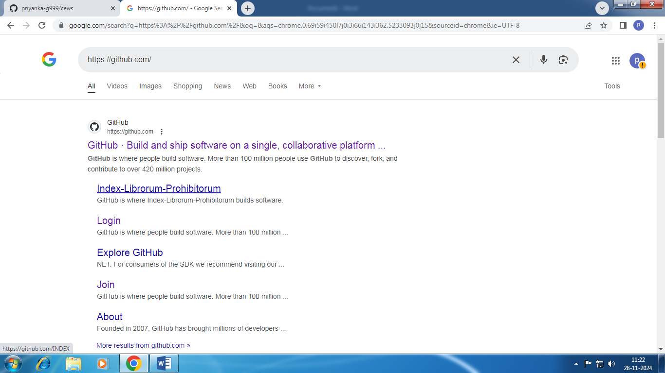

2.CLICK ON THAT LINK ENTER THE REQUIRED EMAIL ADDRESS

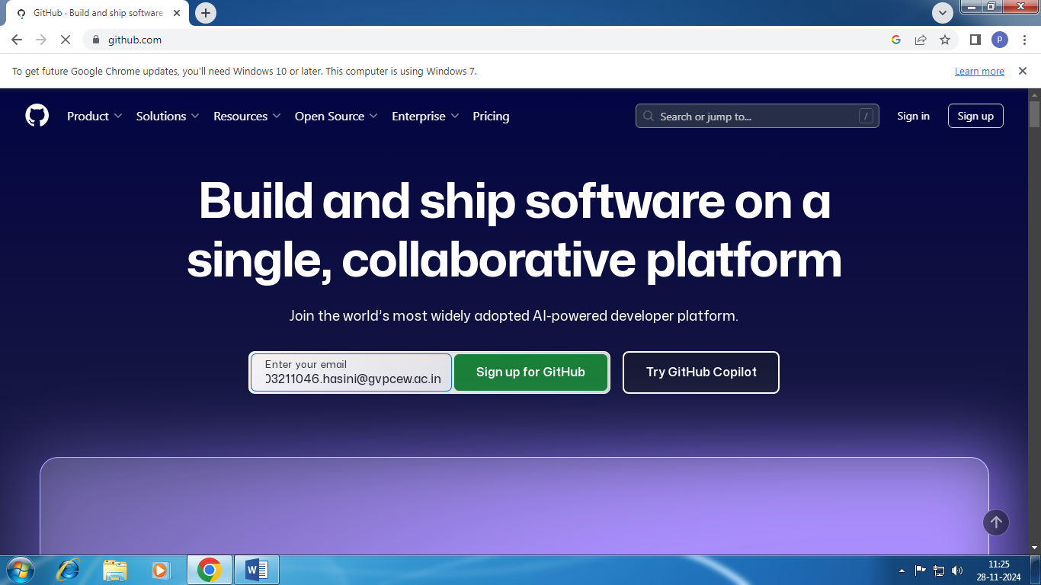

3.SIGN UP FORE GITHUB

4. 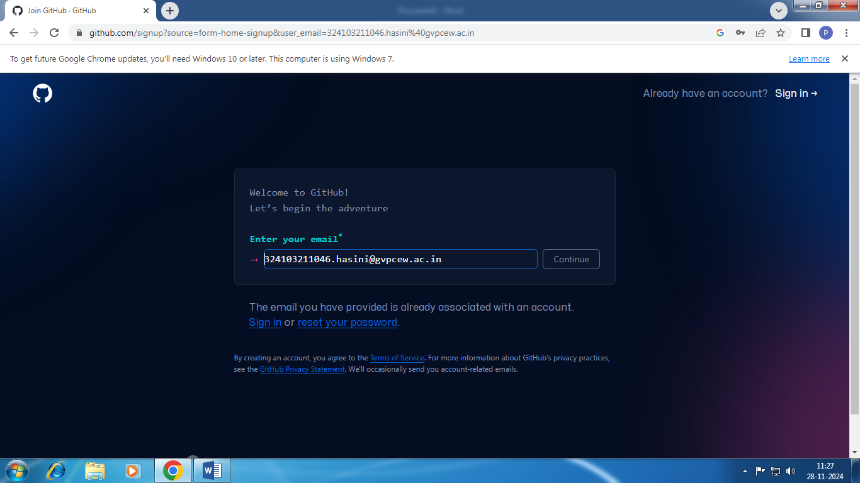

5.CLICK CONTINUE AND ENTER PASSWORD , USERNAME

6.CLICK CREATE AN ACCOUNT

7. VERIFY THE ACCOUNT

8. GITHUB ACCOUNT IS CREATED

